*Directions:  Show all work, and answer each question that is asked.  Explanations should be given in complete sentences.  All graphs should be drawn accurately on this sheet, and be fully labeled.*

1. Let $y = f(x)$ be given by the graph below. Sketch the graph of each of the following. Label at least 3 points on each graph.

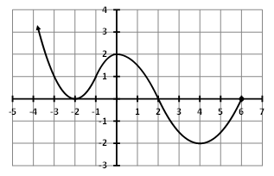

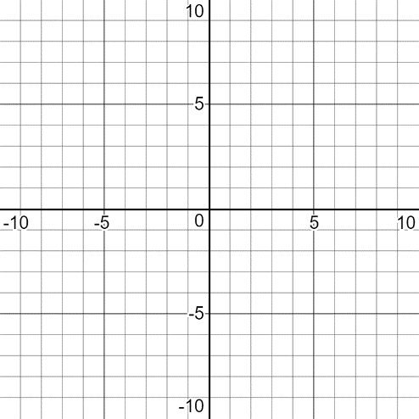

$y=f\left(3x\right)+2$

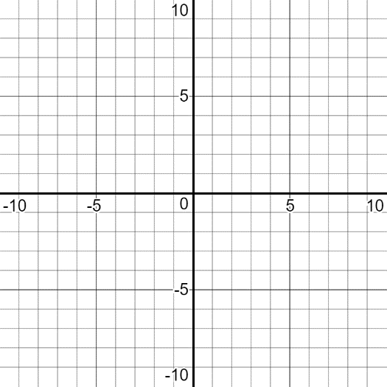

$y=-f(x-2)$

1. 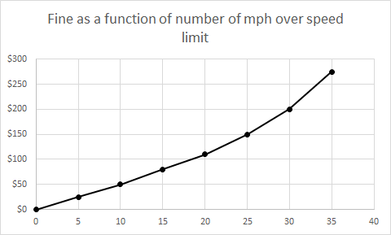On most state highways, the fine for speeding depends on the speed of the car. In a certain state, suppose the fine as a function of the number of miles per hour over the speed limit is $f(n)$. The graph of this function is shown below.

For each of the following situations, write a function, in terms of $f(n)$, that describes the new fine function.

* 1. The state determines that the fine at every speed should go up by $20.
  2. The state determines that the fines at every speed should be tripled in construction zones.
  3. The state decides to adjust all fines in such a way as to give a 10 mph “buffer”. (For example, the new fine for driving 30 mph over the speed limit will be the same as the current fine for driving 20 mph over the speed limit.)

1. The graph of $y=g(x)$ is given below. Sketch an accurate graph of $y=\frac{1}{3}g\left(x\right)-3$ on same set of axes. Label at least 4 points on your new graph. Give the domain and range of the original and the transformed function.

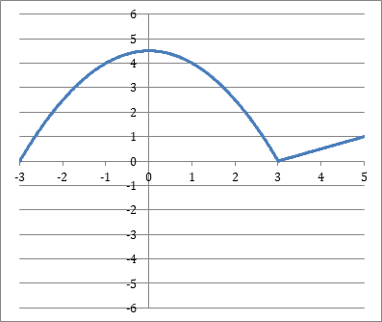

Original function: New function:

**Domain: Domain:**

**Range Range:**